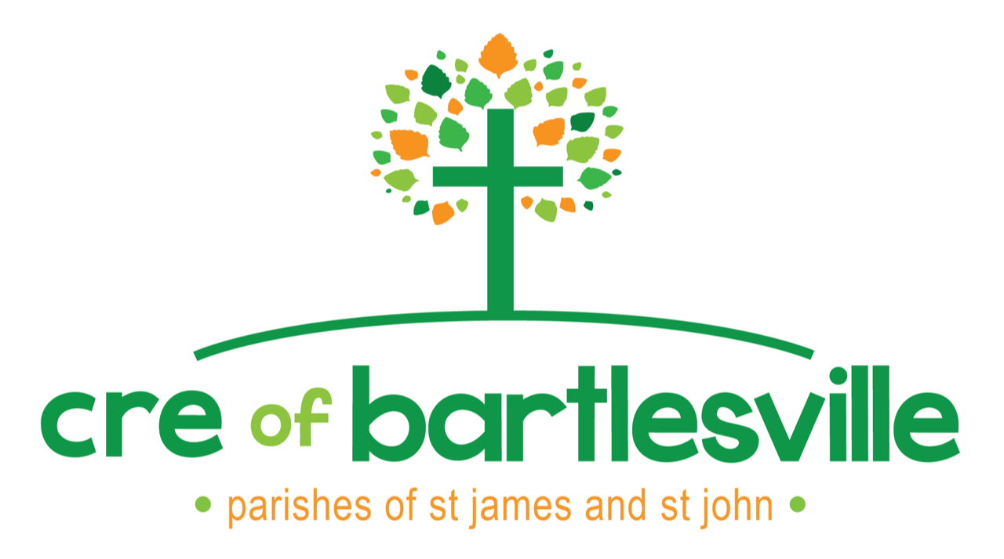
2021-2022 Calendar

Kindergarten – 8th Grade
6:00-7:15pm
Contact us: crebartlesville@gmail.com

** all dates are subject to change as needed**

August | September | October
Registration  (pick up form in person at each parish or online at St. John parish website) | 1st  (Parent Meeting and Cookout)  8th  15th  22^{nd (MS Youth Group)}  29th | 6th  13th (No Class – Fall Break)  20th (Self Safety& Ask Fr. John night)  27th
November | December | January
3rd  10th (Confession Wednesday)  17th (MS Youth group)  24th (No Class – Thanksgiving Break) | 1st  8th  15th (Christmas Parties)  22nd (No Class – Christmas Break)  29th (No Class – Christmas Break) | 5th  12th (Girl’s faith lesson)  19^{th (Boy’s faith lesson)}  26th
February | March | April/May
2nd  9th (MS youth group)  16th  23rd (Confession Wednesday) | 2nd (No Class – Ash Wednesday)  9th  16th (No Class – Spring Break)  23rd (Stations K-4th)  30th (Stations 5-8th) | 6th ⁽MS Youth Group)  13th  20th  27th  May 4th (last cre)
Important Dates 2021-2022 |  | CRE Masses
CRE Parent Meeting & Cookout  September 1st  September 19th  CRE & Catechetical Sunday  @ St. John  First Communion Parent Meeting  September 29th  Self-Safety Class  October 20th  *First Reconciliation  Wednesday, February 2nd 7:00-8:30pm@ St. James for all students | Easter  April 17  *First Communion  Saturday, April 23, 2021  St. John 10am, St. James 2pm  SACRAMENTAL WORKSHOPS:  *Reconciliation Workshop  Wednesday, January 26 6-8pm  *First Communion Workshop/Rehearsal  St. John, Tuesday, April 19th  St. James, Thursday, April 21st  Both from 5:30-8:30pm  *details at parent meeting on Sept 29th | September 19th @ St. John  With Pancake Breakfast and FUN!  March 27th @St. James  with Pancake breakfast and FUN!

