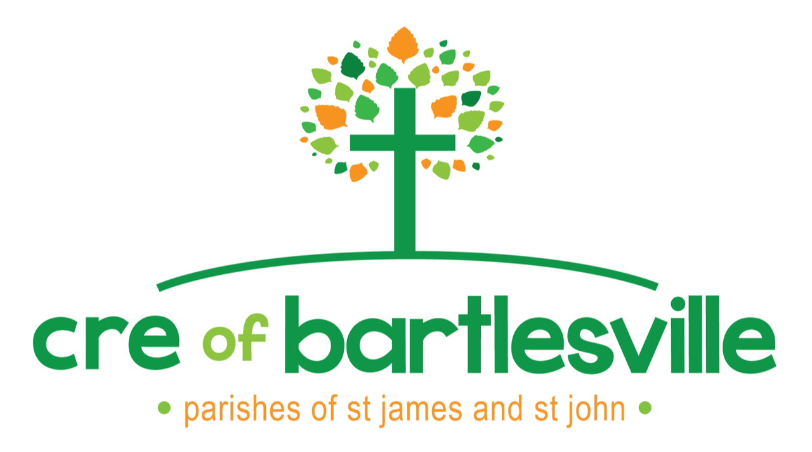
2021-2022 CRE Registration
K-8th grade
St. James & St. John Before the Latin Gate
Bartlesville

Student Information |  |  |  |  | Self-Safety
Last Name | First Name | Grade | Allergies, Handicaps or other Special Needs | Birthday | My child may participate in the Self Safety Program  (See attached information form)
 |  |  |  |  | Yes No
 |  |  |  |  | Yes No
 |  |  |  |  | Yes No
 |  |  |  |  | Yes No

*Which church are you affiliated with? St. James  St. John? 

*May we use photographs of your child/ren for Publicity Purposes to represent the Bartlesville CRE Program? Yes No

Parent Information
Parent / Guardian Name(s)
Street Address
City / ZIP Code
Home Phone
Cell Phone
E-Mail for CRE Communications
(Please print clearly)
Preferred method of communication | Email Text Phone
Primary Language in household | Spanish English Other______________

Emergency Contact Information
Please list an emergency contact in the event we are not able to reach parent/guardian.
Name: Relationship: Phone:

Parent/Guardian Release of Liability
I/We the undersigned parent(s) or legal guardian(s) of (Please list each child) _________________________________________________________________________________________do hereby authorize any x-ray examination, anesthetic, dental medical or surgical diagnosis or treatment by any licensed physician or dentist and/or hospital service that may be rendered to said minor under the general, specific or special request of the St. James & St. John CRE Staff or Volunteers. This consent will remain effective from August 1, 2021 through August 31, 2022. I understand that every precaution will be taken to ensure my daughter/son/ward’s safety. Should an accident occur, I will not hold the St. James or St. John Catholic Church or the Diocese of Tulsa or its paid staff or volunteer staff responsible. Further, I understand that attempts will be made to immediately contact me should an accident occur. If the parish is unable to contact me, I understand that an ambulance or emergency personnel will be notified. Payment for medical emergencies is the responsibility of the parent/guardian.

Parent/Guardian Signature______________________________________Date ___/____/_______

